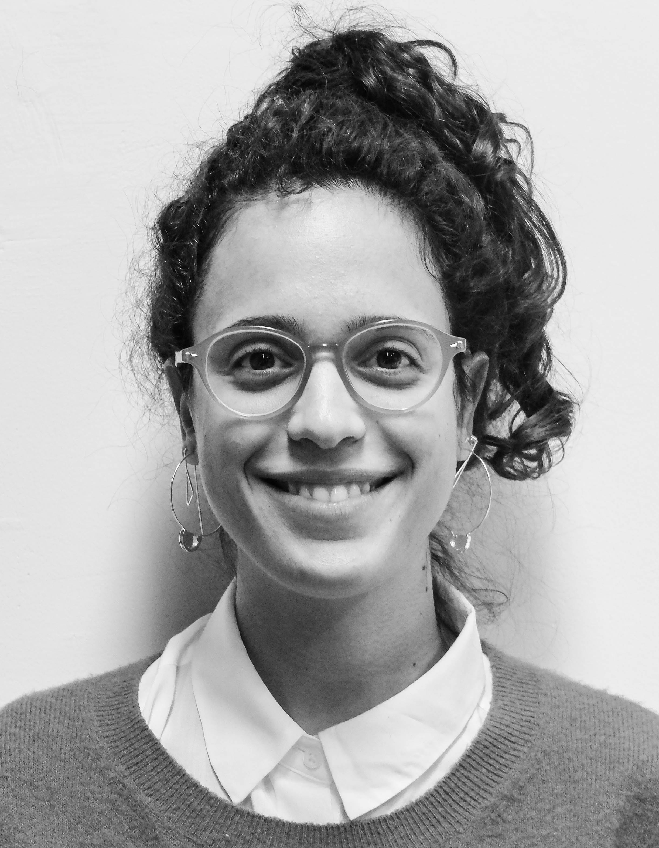CV- Shachar Giladi
Address: 26'Beeri St. Ganey-Tikva, Israel.
Phone number: +972544348527
Email address: giladit2@gmail.com
Website: www.Shachar-Giladi.com
Languages: English and Hebrew- mother tongue, Spanish- medium.
Nationality: Israeli (Dutch husband).
I am a highly motivated, dynamic designer, always a team player, not afraid of difficult situations and perform well under stress.
Education
- 2014-2018: Shenkar College of Engineering and Design.
- 2006-2008: High school, Art Major.
Contests & Awards
- 2018: one of the 3 winners of the Desigul global challenge.
- 2017: one of the top 8 finalists of the global Levi's X Arts Thread design competition.
- 2016-2017: Excellence Academic Award, 3rd year, B.A Fashion design, Shenkar College.
- 2017: one of the top 20 finalists at the Frankfurt Style Award competition.
- 2015-2016: Excellence Academic Award, 2nd year, B.A Fashion design, Shenkar College.
- 2014-2015: Excellence Academic awards, 1st year, B.A Fashion design, Shenkar College.
Exhibitions & Collaborations
- March 2016: collaboration with "Delta group”, Active-wear Project, B.A, Shenkar.
- March 2016: collaboration with "Castro" (an Israeli fashion company), Denim project, B.A, Shenkar.
- October 2015: "Through the Layers” Group exhibition, "Rishon-Lezion" Museum, Israel.
Skills
- Computer skills: Adobe Photoshop, Adobe Illustrator, Optitex.
- Technical Skills: Pattern making, Sewing, Fabric draping, Textile knowledge, Embroidery, knitting, fashion illustration, Cads and Research.
- Specializations: Denim, Menswear, unisex, sustainable fashion, Womanswear, Sportswear, leisurewear, evening gowns and tailored clothing for men.
Experience
- Summer 2017: internship at “River-Island" London, Menswear department:
Cads, research, Menswear Design and development, Denim and Outwear design, embroidery & textile development for Christmas-one of a kind project.
- Summer 2016: internship in a ready to wear Israeli company "Honigman":
Cads, Womenswear, Menswear Design and development for TNT, younger range.
Work and life experience
- Present: head of the Shenkar fashion design department’s Assistant.
- 2011-2014: Manager for the Israeli youth movement "Tzofim" in Ganey Tikva, Israel-
educational and legal responsibility for 700 kids and 10 employees. Got an award for being an excellent worker for 2013-2014.
- 2009-2011: military service as an Infantry instructor for the IDF.
- 2008-2009: A year volunteered with the Ethiopian community at the city Afula, north of Israel. Tutoring emigrants how to read and write both in Hebrew and English.

